NUTRITION
Is the process by an organism obtains or makes food and prepares it for its use.
Its divided into two
1. AUTOTROPHIC NUTRITION which includes photosynthesis and chemosynthesis
2. HETEROTROPHIC NUTRITION

AUTOTROPHIC NUTRITION
Autotrophic (Greek: auto — self; trophic - 'feeding') organisms are those which use an inorganic form of carbon such as carbon dioxide and energy, to form complex organic compounds.
Autotrophic nutrition: This is the mode of feeding in which an organism manufactures its own food from simple inorganic raw materials, from the environment, using energy from the sun or chemical reactions.
There are two types of autotrophic nutrition that is; photosynthesis and chemosynthesis. The former uses light energy while the later uses energy from oxidation of chemical compounds. Photosynthesis is the more common of the two processes and it is used by most plants, algae, some bacteria and protoctists.

Types of Autotrophs
(1) Phototrophs - living organisms in which the synthesis of organic compounds depends on light energy. e.g. all green plants, algae, cyanobacteria, blue-green bacteria, green sulphur bacteria, purple sulphur bacteria, colourless sulphur bacteria.
(2) Chemotrophs - living organisms which use energy extracted from oxidation of inorganic chemicals for the synthesis of organic compounds in a process called chemosynthesis e.g. Nitrosomonas and Nitrobacter

PHOTOSYNTHESIS
This is the process by which green plants/cell containing chlorophyll make complex organic substances /food from simple inorganic molecules of carbon dioxide and water in presence of light energy trapped by chlorophyll and producing oxygen and water as by-products.
Sun light
6CO₂ + 12 H₂O C₆H₁₂O₆ + 6H₂O + 6O₂
Chlorophyll
Note that water is both a raw material and as well a by-product, though not the same water molecules. The reactant water molecules are split to release electrons during the initial light reactions, while the product water molecules are assembled from hydrogen and oxygen released during the light and biochemical reactions.

During photosynthesis, carbondioxide is reduced to carbohydrates and water is oxidized to O₂ gas and hydrogen ions. Thus the process involves both reduction and oxidation known as redox reaction.
I.e. oxidation of water would be:
2H₂O light energy O₂ + 4H⁺ + 4e-

Oxygen evolved is lost to the atmosphere as a by- product of photosynthesis while the hydrogen ions are used in the reduction of CO₂ to carbohydrates.
CO₂ + 4H⁺ + 4e⁻ (CHO) n + H₂O

This implies that the summarized equation of photosynthesis is obtained by combining the 2 equations i.e. the oxidation of water and the reduction of CO₂
6CO₂ + 7H₂O light energy C₆H₁₂O₆ + H₂O + O₂
Chlorophyll

From the above equation the following conclusions are made;
- The carbon in the carbohydrate is obtained from the CO₂ .
- oxygen atoms of the CO₂ are used in formation of the carbohydrate and water released as a by-product of photosynthesis ( metabolic water )
- Oxygen developed as a by-product of photosynthesis comes from the oxidation of water by the process of photolysis.
- The hydrogen atoms in the carbohydrate and metabolic water are obtained from the water as a raw material of the process.

The above conclusions are approved using the Isotope labeling technique i.e. carbon-14 in the CO₂ , oxygen -18 in CO₂ and oxygen — 16 in water. When the above isotopes are used, subsequent testing with a mass spectrometer found that the carbohydrate contained, carbon -14 and oxygen — 18 but the oxygen evolved as a by- product contained oxygen — 16 which was contained in the water molecules.

Importance of photosynthesis
- It provides a source of complex organic molecules for heterotrophic organisms. It makes both carbon and energy available to organisms. All organisms directly or indirectly depend on photosynthesis.
- It releases oxygen into the atmosphere that is used by aerobic organisms for respiration.
- It is the means by which the sun's energy is captured by plants for use by all organisms
- It avails man with fossil fuels
- The process of photosynthesis is a CO₂ sink .i.e. The process reduces on the amount of carbon dioxide in the atmosphere thus controlling global warming
- Photosynthesis together with respiration create a cycling of carbon dioxide (C0₂) and oxygen in the atmosphere

CONDITIONS NECESSARY FOR PHOTOSYNTHESIS
1. Carbon Dioxide
Terrestrial plants obtain carbon dioxide (1) from the atmosphere (where its about 0.03%) via the stomata
(2) By absorbing carbonates from the soil through the roots. Aquatic plants absorb dissolved bicarbonates through their general surface to carbon dioxide.
2. Water
Water provides the H⁺ ions and electrons for the reduction of carbon dioxide in oxygenic photosynthesis of all organisms.

2H₂O light energy O₂ + 4H⁺ + 4e-

4H⁺ + CO₂ CH₂O + H₂O

Experiments conducted using isotropically enriched oxygen (¹⁸O₂) also proves that all of the oxygen produced in photosynthesis is derived from water and none from carbon dioxide.

3. Light
The three properties of light that are of importance to organisms are (i) spectral quality/colour (ii) intensity/brightness (iii) duration/time.
Light is electromagnetic energy propagated in discrete particles called photons or quanta.

4. Photosynthetic Pigments
The photosynthetic pigments which are of two categories:
(1) Chlorophyll
(2) carotenoids take part in absorption of light energy for the purpose of photosynthesis.

Main photosynthetic pigments and their distribution
Photosynthetic Pigment | Distribution (occurrence) | Properties/colour
1.CHLOROPHYLLS  Chlorophyll a | All photosynthetic plants  i.e. It is the most abundant because of its universal occurrence | lBlue- green in pure state  lEmpirical formula: C₅₅H₇₂N₄O₅Mg  lVery soluble in ether, and also soluble in lipid solvents e.g. chloroform, carbon tetrachloride, alcohols, etc
Chlorophyll b | Higher plants and green algae | lyellow-green in pure state.  lEmpirical formula: C₅₅H₇₀N₄O₆Mg  lVery soluble in methyl alcohol and also soluble in lipid solvents e.g. chloroform, carbon tetrachloride, etc
Bacteriochlorophyll | (1) Purple sulphur Bacteria,  (2) Chloracidobacterium thermophilum  (3) Green sulfur bacteria | l Are related to chlorophylls  lConducts photosynthesis, but do not produce oxygen.  lAbsorbs wavelengths of light not absorbed by plants e.g. 750-1040 nm
Bacterioviridin | Chlorobium photosynthetic bacteria | lOccurs as esters of farnesol.  lEmpirical formula: C₅₁H₆₇O₄N₄Mg
Chlorophylls C | Diatoms and Brown algae | lColouration: golden or brownish  lAre accessory pigments.  lGather light but is not used in photosynthesis itself
Chlorophyll d | Cyanobacteria  e.g. Acaryochloris marina | lAbsorb far-red light, at 710 nm wavelength, just outside the optical range but Acaryochloris marina, a bacterium, uses it for photosynthesis.
Chlorophyll f | Cyanobacteria e.g. stromatolites from Western Australias Shark Bay. | Absorb infrared light.  l Function not known.
2.CAROTENOIDS  (a) xanthophylls  α-carotene  (b) carotenes β-carotene and lycopene | Naturally occurring in chloroplasts and chromoplasts of plants and some other photosynthetic organisms like algae, some bacteria, and some types of fungi | l xanthophylls contain oxygen.  l carotenes are purely hydrocarbons, and lack oxygen.  lIn general absorb blue light.  lserve two key roles in plants and algae: (1) absorb light energy for use in photosynthesis, (2) protect chlorophyll from photo damage.  lCarotenes are unsaturated hydrocarbons.  lXanthophylls are often yellow.  l Carotenes vary in colour: pale yellow, bright orange, deep red.  Generally, carotenoids are antioxidants in humans and work to prevent the effects of aging.  l Are soluble in fat solvents like ether, chloroform, acetone, carbon disulphide.  lCarotenes are closely related to the vitamin A, with mpirical formula is C₄₀H₅₆.  l Xanthophylls have empirical formula is C₄₀H₅₆O

Chlorophyll belongs to a class of organic compounds called porphyrins and bears a close resemblance to the chemical structure of haem and the cytochromes.
Chlorophyll b and carotenoids are called accessory photosynthetic pigments because they hand over the energy absorbed by them to chlorophyll a.

CAROTENOIDS serve two key roles in plants and algae:
(1) Absorb light energy and pass it over to chlorophyll a for use in photosynthesis,
(2) Protect chlorophyll from being destroyed by excess light/photo damage and from oxidation by oxygen produced by photosynthesis.
3) They provide bright and attractive colours to the leaves/bracts for attraction of insects for pollination and to fruits to attract agents of dispersal.

ABSORPTION AND ACTION SPECTRA

Absorption spectrum (A);
This is the graph showing the relative amount of light absorbed at different wave lengths by photosynthetic pigments/chlorophyll.

The absorption of radiation by a substance can be quantified with an instrument called a spectrophotometer

Action spectrum of photosynthesis
A graph of the effectiveness of different wavelengths of light in stimulating the photosynthetic process.

This is the graph showing the amount of photosynthesis occurring at each wave length. It is measured in terms of O₂ produced at each wave length. It is obtained by subjecting light of these same wave length in turn for a unit of time on to aquatic pond weed the gas evolved is collected and its volume measured (rate of O₂ production is a measure of the rate of photosynthesis.
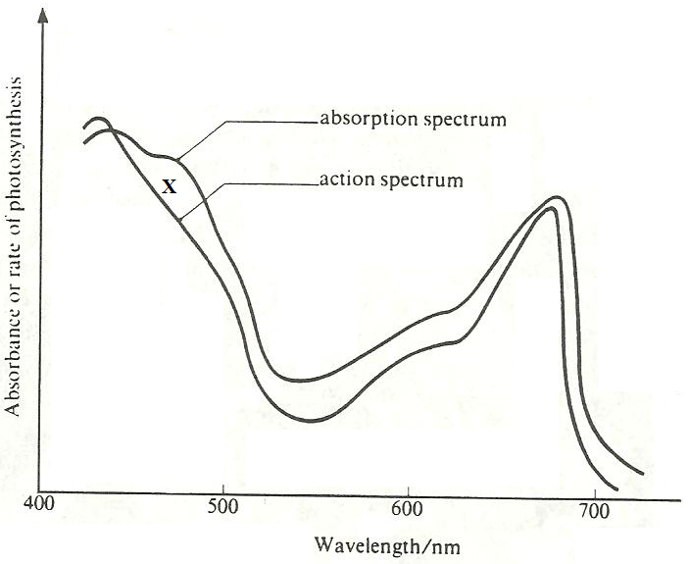
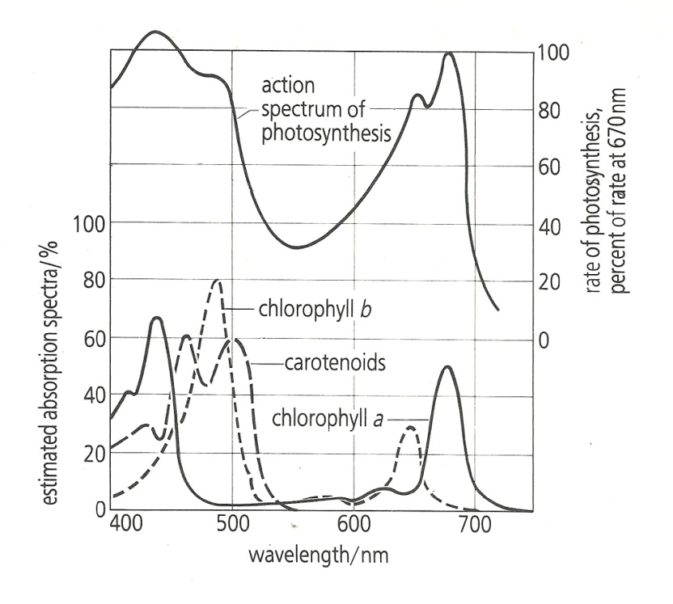
Graph B

Conclusions from graph A
- carotenoids absorb the largest amounts in the violet blue region of light
- chlorophyll b absorbs more blue light than red light
- Chlorophyll a absorbs both blue and red light in large amounts.
- There is very low light absorption of green light by chlorophyll and none for the carotenoids.

Conclusions from graph B
- Red and blue light is the most effective wave length for photosynthesis
- The more the absorption of light the higher the rate of photosynthesis; the action spectrum shows a dose correlation with the absorption spectrum of chlorophyll a and b

Observations | Interpretations
l The action spectrum of photosynthesis corresponds closely to the absorption spectra of chlorophyll a and b. | l This indicates that most of the wavelengths of light absorbed by chlorophyll are used in photosynthesis.
l There is non-correspondence of action spectrum of photosynthesis with absorption spectra at point marked X | l This is because it is at X where there is maximum absorption by carotenoids, which are not used in photosynthesis.
l The wave lengths of about 550 nm to 620 nm have the lowest absorption and action spectra for all the photosynthetic pigments. | l The unabsorbed (reflected light) appears green, thus making chlorophyll, the chloroplasts and the leaves that contain it appear green to our eye.
l There are two absorption maxima of lambda= 430 nm and lambda= 662 nm for chlorophyll a, and 453 nm and 642 nm for chlorophyll b, but only one maximum for carotenoids at about 510 nm. | l This shows that chlorophyll a as well as b are the main photosynthetic pigments, however, photosynthesis also occurs in the mid part of light spectrum where carotenoids are active.
l The action spectrum peaks within the blue-violet and red regions of the light spectrum | l This shows that maximum photosynthesis occurs in red part and blue-violet part of visible light.
OTHER OBSERVATIONS
l Chlorophyll a absorption in red light is about twice that of chlorophyll b and the absorption peak is at a slightly longer wavelength (lower energy)
l Absorption of chlorophyll a in the blue is lower and shifted to a slightly shorter wavelength (higher energy).

ADAPTATIONS OF CHLOROPLASTS FOR PHOTOSYNTHESIS
- Membrane system composed of flattened fluid sacs called thylakoids i.e. the grana and the intergrana to increase surface area for maximum absorption of sun light by chlorophyll molecules.
- The outer membrane is thin, transparent, permeable towards respiratory gases/CO₂ and O₂
- Matrix known as stroma contains enzymes that catalyze the reactions of the dark stage of photosynthesis.
- In the thylakoid system, there is a system of different electron carriers existing at different energy levels via which emitted electrons by excited chlorophyll molecules are transferred to release energy used to form ATP from ADP and phosphate.

ADAPTATIONS OF LEAVES FOR PHOTOSYNTHESIS
Adaptations for obtaining sunlight
1. Phototropism causes shoots to grow towards the light in order to allow maximum illumination.
2. Etiolation causes rapid elongation of shaded shoots to enable leaves capture light as soon as possible.
3. The mosaic leaf arrangement minimizes leaf overlap and reduces leaves shading each other.
4. Its broad to have a Leaf large surface area for capturing maximum sunlight.
5. Its thin to allow easy diffusion of CO₂ and maximum light penetration.
6. The transparence of leaf cuticle and epidermis allow light penetration into the photosynthetic mesophyll beneath.
7. The palisade mesophyll cells are densely packed with chloroplasts and arranged with their long axes perpendicular to the surface to form a continuous layer which traps most of the incoming light.
8. Cyclosis (movement of chloroplasts within the mesophyll cells) allows them to arrange themselves into the best positions for efficient absorption of light.
9. The chloroplasts hold chlorophyll in an ordered / structured way on the sides of the grana to present maximum chlorophyll to the light and also bring it close to other pigments / substances necessary for functioning.
10. In leaves of sun plants the palisade layer, whose cells are densely packed with chloroplasts is more than one cell thick to increase on photosynthetic efficiency.
11. In leaves of shade plants, the cells of palisade and spongy mesophylls are densely packed with chloroplasts to increase on light trapping hence photosynthetic efficiency.
Adaptations for gas entry and exit
1. Numerous stomata are present in the epidermis of leaves to enable entry (CO₂) and exit of gases (O₂).
2. The guard cells bordering stomata pores can be opened and closed to regulate the uptake of carbon dioxide and the loss of water.
3. Spongy mesophyll possesses much airspace to enable faster and uninterrupted diffusion of gases between the atmosphere and the palisade mesophyll which wouldnt happen if the gases were to diffuse through the cells themselves, a process which would be much slower.
Adaptations for liquid entry and exit
1. A large central midrib containing a large vascular bundle comprising xylem and phloem tissue is possessed by most dicotyledonous leaves for the entry and transport of water and mineral salts, and the phloem for carrying away sugar solution, usually in the form of sucrose.
2. A network of small veins is found throughout the leaf to ensure that every cell is close to xylem vessel or phloem sieve tube for constant supply of water for photosynthesis and a means of removing the sugars they produce.

MECHANISM OF PHOTOSYNTHESIS

Photosynthesis is an oxidation-reduction process, in which water is oxidized to release oxygen and carbon dioxide is reduced to form carbohydrates. Photosynthesis occurs in two phases
(1) Photochemical reactions (also called light or Hill reaction) and
(2) Biochemical reactions (also called dark or Blackman s reaction.
Photosynthesis basically divided into 2 stages
- Light dependant stage
- Light independent stage or dark reaction

LIGHT DEPENDENT STAGE
It takes place in the thylakoid membranes of chloroplasts.
The main functions are:
(1) Photophosphorylation i.e. formation of Adenosine triphosphate (ATP) by the addition of an inorganic phosphate to Adenosine diphosphate (ADP) using light energy.
(2) Formation of NADPH⁺ which is the reduced form of Nicotinamide adenine dinucleotide phosphate.
The light dependent stage involves 3 major events
- Photolysis of water ; splitting of water
- Formation of NADPH⁺ ; reducing agent.
- Photophosphorylation; addition of phosphorous.
This is a stage of photosynthesis that requires light energy which is absorbed by the photosynthetic pigments (chlorophyll) found in the thylakoids of the chloroplast.
These pigments are located in special reaction centres called photosystems. These systems convert the absorbed light energy (photons) into chemical energy (in form of ATP)
Hills reaction involves 3 major events

- Photolysis of water; is the splitting of water using sunlight energy absorbed by chlorophyll.
Water used as a raw material for photosynthesis is chemically oxidized (split) by using light energy (protons) absorbed by chlorophyll molecules into an oxygen molecule, hydrogen ions and 4 electrons
2H₂O light energy 4H⁺ + O₂ + 4e⁻
The oxygen produced by photolysis of water is evolved to the atmosphere as a by-product of photosynthesis. The protons (H⁺ ) are used to reduce NADP⁺ to NADPH + H⁺ . The protons of the hydrogen ions are used in the dark stage of photosynthesis to reduce CO₂ to carbohydrates.

- Formation of NADPH₂ i.e. reduced NADP

Also known as Nicotinamide adenine dinucleotide phosphate Hydrogen. This event involves reduction of oxidized NADP in the presence of two hydrogen ions and electrons obtained from the photolysis of water. Reduced NADP is one of the products of the light stage. its purpose is to carry hydrogen from the light to the dark stage for the reduction CO₂ to carbohydrates in the presence of NADP- reductase;
NADP +2H⁺+2e⁻ NADP-reductase NADPH₂

- Photophosphorylation
The synthesis of high energy chemical compound, ATP from Adenine Diphosphate (ADP) and a free inorganic phosphate by using energy emitted by photo-excited electrons/using the sun light energy absorbed by photosynthetic pigments in the presence of the ATPase enzyme.
The energy used the in the formation of ATP molecules is lost by excited electrons as they are carried from higher to lower energy levels. Through this process, solar energy that excites electrons is converted into chemical energy.
ADP + P_{i} ATPase enzyme ATP (high energy chemical compound)
Light energy
N.B: phosphorylation:-involves addition of a free inorganic phosphate to Adenine Diphosphate (ADP) forming a high energy compound ATP.
ADP +P_{i} ATP

Mechanism of photophosphorylation

Light energy in form the photons is absorbed by the photosynthetic pigments in the reaction centres called photosystems .In each photosystem, there are several chlorophyll molecules and accessory pigments i.e. carotenes and xanthrophyll which all harvest light energy and pass it onto chlorophyll a in the reaction centres each pigment absorbs light of different wave length
There are 2 types of photosystems
i.Photosystem 1 (PSI)
With chlorophyll a molecule called P-700 which absorbs light of wave length 700 nm which functions as reaction centre. In P700 photochemical reaction takes place. The pigment system I is located on both the non-appressed part of grana thylakoids and stromal thylakoids.

ii .photosystem II (PSII)
With chlorophyll a absorbing light of wave length 680nm (p 680) light energy absorbed excites electrons which are raised to higher energy levels and then get accepted by electron carriers (coenzymes). The lost electrons are replaced by the ones from photolysis of water or from photosystem II. This system is located in the appressed part of grana thylakoids only.

There are 2 types of photophosphorylation
- cyclic photophosphorylation
- non-cyclic photophosphorylation

Non cyclic photophosphorylation
This is the formation of ATP from ADP + P_{i} using energy emitted by photo-excited electrons as they flow unidirectionally through electron carriers from PSII/p680 to PSI/p700.

The light stage reactions are triggered by light energy exciting photosystems I and II inside the thylakoid membranes at the same time, not one after the other.
Chlorophyll molecules of PSII and PSI are excited by light of wavelength 680 nm and 700 nm respectively; causing the loss of electrons to a chain of electron carriers in a series of reduction-oxidation reaction.

This path way consists of 2 pigment systems of chlorophyll
Pigment system1 (phototosystem1) and pigment system II (photosystem II)
The 2 systems are at different energy levels
Photosystem II is at the lower energy level compared to PSI. When both photosystems are struck by sun light of appropriate wave length, they get excited and loose electrons. Electrons from PSII are raised to a higher energy level and accepted by the electron carrier known as plastoquinone (PQ).
Electrons lost from a photosystem II (PSII) are replaced by the ones from photolysis of water in order to restore its neutrality i.e
2H₂O light energy O₂ + 4H⁺ + 4e- (free electrons used to restore the neutrality of PSII).photolysis is the splitting up of water molecules into hydrogen and oxygen using sun light energy trapped by chlorophyll.
The electrons from PSII flow from PQ down through a chain of electron carriers to PSI to replace the lost electrons. As the electrons are carried from a carrier at a higher energy level to one at a lower energy level, energy is lost that is used in phosphorylation (ATP synthesis from ADP and P_{i} ). The electrons are received by PSI/p700 which becomes restabilised.
The electrons from PSI/p700 are then passed on another electron acceptor, Ferrodoxin and combine with hydrogen from photolysis of water.
The electrons and hydrogen reduce Nicotinamide adenine dinucleotide phosphate (NADP) to form reduced Nicotinamide adenine dinucleotide phosphate /NADPH.
In the presence of hydrogen ions from the photolysis of water reduced NADP⁺ is used in the dark reactions by providing hydrogen used to reduce CO₂ to carbohydrates. The formed ATP molecules are used in the dark reactions.

The main Products of non — cyclic photophosphorylation therefore are ATP, Reduced NADP/ NADPH₂ while the by-product is Oxygen
Non-cyclic photophosphorylation is also called the Z scheme because it involves flow of electrons from light excited chlorophylls in Ziz Zag pattern via chains of electron carriers to form ATP and reduced NADP/NADPH

Electron transport and non — cyclic photophosphorylation in photosynthesis

Cyclic photophosphorylation:
Is the synthesis of ATP from ADP and P_{i} coupled to the cyclic passage of electrons along a series of electron transport molecules to and from photosystem I (P700). OR
It is the formation of ATP from ADP + Pi using energy emitted by photo-excited electrons of P700 as they flow along photosynthetic electron carriers and back to photosystems I (P700).

In this phosphosphorylation, light energy absorbed by PSI boosts electrons to a higher energy level that excited electrons are accepted by a ferrodoxin (electron acceptor) . From ferrodoxin, electrons are recycled back in PSI directly via a series of electrons carries which are at different energy levels.
The energy lost by the electrons as they are returned to PSI is captured and released in the synthesis of ATPs from ADP and an in organic phosphate
By so doing, light energy is converted to chemical energy. The only product of cyclic photophosphorylation is ATP and involves only PSI
NOTE: Cyclic photophosphorylation takes place most efficiently when the dark reaction is prevented by either
(1) Absence of hydrogen acceptor NADP
(2) Lack of carbondioxide.
Electron transport and cyclic photophosphorylation in photosynthesis

CYCLIC AND NON-CYCLIC PHOTOPHORYLATION COMPARED
Similarities
In both:
(1) There is flow of electrons through several electron carriers
(2) There are photosystems which accept and lose electrons.
(3) ATP is formed.
(4) pigment system I is involved
(5) Electron movement is located in the thylakoid membranes
(6) Protons are moved outwards of the thylakoids.
(7) Protons (H⁺) are actively pumped from stroma into thylakoid space.
(8) There is photo-excitation of electrons in the pigment systems.

Differences
NON-CYCLIC PHOTOPHORYLATION | CYCLIC PHOTOPHORYLATION
l Electrons flow unidirectionally (non-cyclically) | l Electrons flow cyclically
lFirst electron donor is (source of electrons) water | lFirst electron donor is pigment system I (PSI)
lLast electron acceptor is NADP | lLast electron acceptor is pigment system I (PSI)
lThe products are ATP, NADPH and Oxygen | lThe product is ATP only
lInvolves both pigment systems I and II | lInvolves only pigment system I
lPhotolysis of water occurs | lNo photolysis of water

Differences between PSI and PSII
PSI | PSII
- Restabilised by electrons from PSII | stabilized by electrons from water
- Involved in both cyclic and non-cyclic photophosphorylation | Involved in non-cyclic photophosphorylation
- Is not associated with photolysis of water | Is associated with photolysis of water
- PSI is at a higher energy level | PSII is at a lower energy level
- Its reaction centre is P7oo | Its reaction centre is P680

Chemiosmotic theory of ATP synthesis (theory of photophosphorylation)

Photolysis of water by light absorbed by chlorophyll in PSII, releases protons/H⁺ ions, electrons and oxygen. The electrons are passed along a chain of electron carriers and as they move from one electron carrier to another carrier energy is released.

The flow of electrons through electron carriers in the thylakoid membranes releases energy for active pumping of hydrogen ions (H⁺) from the stroma across a thylakoid membrane to the thylakoid space/thylakoid compartment/ lumen/cavities.

The protons/Hydrogen ions accumulate in the thylakoid space/cavity; creating a proton gradient/ steep electrochemical gradient in the lumen of the thylakoid membranes than in the stroma, leading to the rapid diffusion of hydrogen ions ( H⁺ ions) along the steep electrochemical gradient back to the stroma through specific channels called chemiosmotic channels / via the stalked particles. These channels are formed by an enzyme complex called ATP synthase/ATPase. As protons pass through the channels; the enzyme ATPase converts ADP and inorganic phosphate into ATP. Also the potential energy stored in proton concentration difference is used to generate ATP from ADP and inorganic phosphate in presence of ATPase
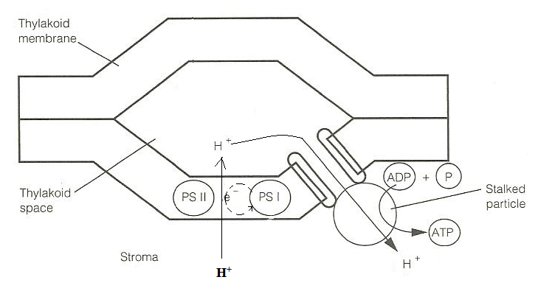

Qn .The synthesis of ATP is driven by a flow of protons. Describe where and how the required proton gradient is produced in the chloroplast.

LIGHT INDEPENDENT OR DARK STAGE
Its called dark reaction because does not require light, although can take place in light also.

THE MAIN PATHWAYS FOR THE DARK REACTION
(l) Calvin-Benson cycle / C₃ pathway
(2) Hatch-Slack pathway / C₄ pathway

It occurs in a cycle of reactions called the Calvin cycle named after Melvin Calvin and It occurs in the stroma of chloroplasts of C₃ -plants. The major purpose of the dark reaction is to reduce the CO₂ absorbed from the atmosphere and water to the carbohydrates.

This requires ATP and reduced NADP (NADPH+ H⁺) from the light stage of photosynthesis. ATP provides energy for the endergonic with action reaction of the dark stage and reduced NADP provides hydrogen atoms required to reduce CO₂ to carbohydrates.

C₃ CYCLE: is the series of reactions in plants to form glycerate-3-phosphate (which has 3 carbons) as first organic substance during photosynthesis.

C₃-Plants are plants that fix CO₂ directly in glycerate-3-phosphate/ G.P which is a 3 carbon organic compound as the first stable product during photosynthesis. OR
These are plants whose first stable compound of carbon dioxide fixation is a 3 carbon organic compound called PGA/G.P/Phosphoglycerate.

MAIN STAGES OF THE CALVIN-BENSON CYCLE (C₃ CYCLE)

1. Carboxylation stage
During this stage carbondioxide fixation occurs in the stroma of the chloroplast of the mesophyll cells.
CO₂ which has diffused into the stroma of the chloroplast reacts with 5 carbon compound, ribulose Bisphosphate under the catalysis of ribulose Bisphosphate carboxylase enzyme/RUBISCO to produce an unstable 6 carbon compound.
The 6carbon compound splits up into two molecules of 3 carbon compound, the first stable product of phosynthesis called phosphoglyceric acid ( PGA) or glycerate -3- phosphate /phosphoglycerate .
Some of the Phosphoglycerate is used for the synthesis of amino acids and fatty acids needed for the synthesis of proteins and lipids respectively.
The fixing of CO₂ by RUBP is called carboxylation of RUBP or carbon dioxide fixation i.e.
CO₂ + RUBP (5C) RUBP unstable 6C organic compound
Carboxylase
.2. Reduction stage
The remaining and biggest portion of phosphoglycerate is reduced by hydrogen donated by reduced NADP, using energy from hydrolysis of ATP to form phosphoglyceraldehyde (PGAL)/triose phosphate/glyceraldehydes-3-phosphate/GALP/3-phosphoglyceraldehyde.
Water molecules are released as PGA is reduced to the Aldehyde PGAL
ATP ADP
PGA/G.P PGAL + H₂O
NADPH+H⁺ NADP⁺

Part of PGAL is used for the synthesis of glycerol.
The triose phosphate is the end product of photosynthesis.
3. Isomerisation and condensation

The remaining and biggest portion of PGAL passes via a series of reactions and is used to form Monosaccharide sugars mainly hexose sugars which condense into sucrose and starch. i.e. Two of the 3-phosphoglyceraldehyde molecules undergo isomerisation and several reactions to form fructose-1-phosphate and glucose-1-phosphate, both of which may condense to form sucrose or starch.

4. Regeneration of ribulose Bisphosphate (RUBP)
Another portion of PGAL is used for regeneration of RUBP via several enzyme catalyzed reactions, using energy from hydrolysis of ATP into ADP.
In regeneration of RUBP; 5 PGAL are used to regenerate 3 RUBPs .this process require ATPs and re arrangement of the carbon atom in the sugar phosphate to generate 5 carbon compounds from 3 carbon compounds
3ATP 3ADP+ 3P_{i}
5 PGAL rearrangement of carbon chain 3RUP 3RUBP

5. Product synthesis stage:-

Product of photosynthesis (T.P) is assimilated through different pathways some of which are:-
- Is converted into sucrose; a form in which its translocated either in storage organs or growing points.
- It is fed into the glycolytic pathway (respiration) to produce energy required for endergonic reactions. T.P/GPAL enters the Glyccolytic pathway where it is converted into acetyl CO.A which enters the Krebs cycle

Synthesis of lipids:-lipids are formed from glycerol which is formed directly from T.P/PGAL and fatty acids which are obtained from phosphoglycerate/PGA/G.P.
PGA/G.P enters the glycolytic pathway to form Acetyl co-enzyme A which is then used to synthesis fatty acids, which finally react with glycerol through condensation reaction forming lipids.

Synthesis of proteins: - The Triose Phosphate is fed into Krebs cycle after converting it to Acetyl co.A.
PROTEINS are formed from amino acids which are also formed from phosphoglycerate/glycerate-3-phosphate.
Phosphoglycerate via the acetyl CO.enzyme A, forms an intermediate organic acid of the krebs cycle.
The intermediate krebs cycle acid reacts with ammonia from the reduction of nitrates obtained from the soil to form amino acids which are used in protein synthesis.
The nitrites are obtained from reduction of nitrates using reductase enzyme as show below.
NO₃⁻(aq) nitrate NO₂⁻(aq) Nitrite NH₃
Reductase Reductase
NH₃ + krebs cycle acid intermediate organic acid amino acids

SUMMARY OF THE CALVIN CYCLE

Question
Chlorella (unicellular organism) was allowed to photosynthesize at high and very low carbon dioxide levels .the concentration of G.P and RUBP was investigated.
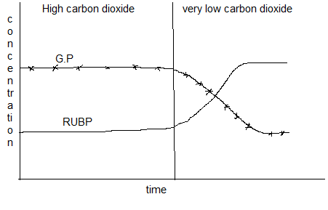

a) Account for the different concentration of RUBP during the whole course of the investigation
b) Explain why the concentration of GP fall when the level of carbon dioxide is reduced.

LIGHT INDEPENDENT MECHANISMS OF PHOTOSYNTHESIS IN C₄-PLANTS.

C₄ Plants are the ones whose first formed stable compound of carbondioxide fixation is a 4 carbon organic compound known as oxaloacetate.

Plants that produce the 3 carbon compound as the first stable product of photosynthesis of carbondioxide fixation are called the C₃ plants.
C₄ plants found in maize, sugar cane, millet, sorghum, and many tropical grasses. These are plants which are mainly monocots that produce a 4 carbon compound called oxalo acetic acid (OAA) as the first stable product of carbondioxide fixation.
They undergo two pathways of photosynthetic reactions which includes the Hatch-slack pathway and the Calvin cycle.

Hatch-slack pathway
A type of photosynthesis in which CO₂ is first, fixed by phosphoenol pyruvate catalyzed by PEP carboxylase (PEP) into Oxaloacetate (OAA) inside mesophyll cells, stored as organic acid (mainly malate) which is later decarboxylated, refixed and CO₂ is assimilated in the Calvin‐cycle inside bundle sheath cells.

Hatch-slack pathway Involves transportation of hydrogen and carbondioxide from the mesophyll cells into the bundle sheath cells.

During this pathway Carbondioxide is fixed by a 3 carbon compound called phosphoenol pyruvate (PEP) in the cytoplasm of the mesophyll cells under the catalysis of phosphoenol pyruvate carboxylase enzyme to form a stable 4 carbon organic compound called oxalo-acetate (OAA).
PEP PEP carboxylase Oxalo-acetate (4C)

Oxalo-acetate (OAA) is reduced by hydrogen from Nicotinamide adenine dinucleotide phosphate Hydrogen /reduced NADP to form a 4 carbon compound called Malate. Fixation of CO₂ by PEP to form Malate occurs in the mesophyll cells.
OAA (4C) Malate (4C)

NADPH₂ NADP+
The malate produced in the mesophyll cells diffuses through the plasmodemata and then diffuses into the chloroplast of the bundle sheath cells.
Within the chloroplasts of the bundle sheath cells, malate is dehydrogenated to give large amount H ⁺ ions and decarboxylated to form CO₂ and pyruvate. The C₄ path way pumps CO₂ and H⁺ ions into the bundle sheath cells where they are used by the normal Calvins cycle.

CO₂ Calvin cycle
Malate (4C) pyruvate (3C)

NADP+ NADP H₂

The H⁺ ions produced are used to reduce NADP to form reduce NADP/NADPH whose synthesis is limited to a bundle sheath cells.
The formed CO₂ in the bundles Sheath cells is fixed by RUBP under the catalysis of RUBP carboxylase to form organic food substances via a series of reactions.
Regeneration of PEP
The pyruvate diffuses back into the mesophyll cells where it is phosphorylated using 2 molecules of ATP to regenerate the carbondioxide acceptor, PEP.

Pyruvate (3C) PEP (3C)

ATP ADP +P_{i}

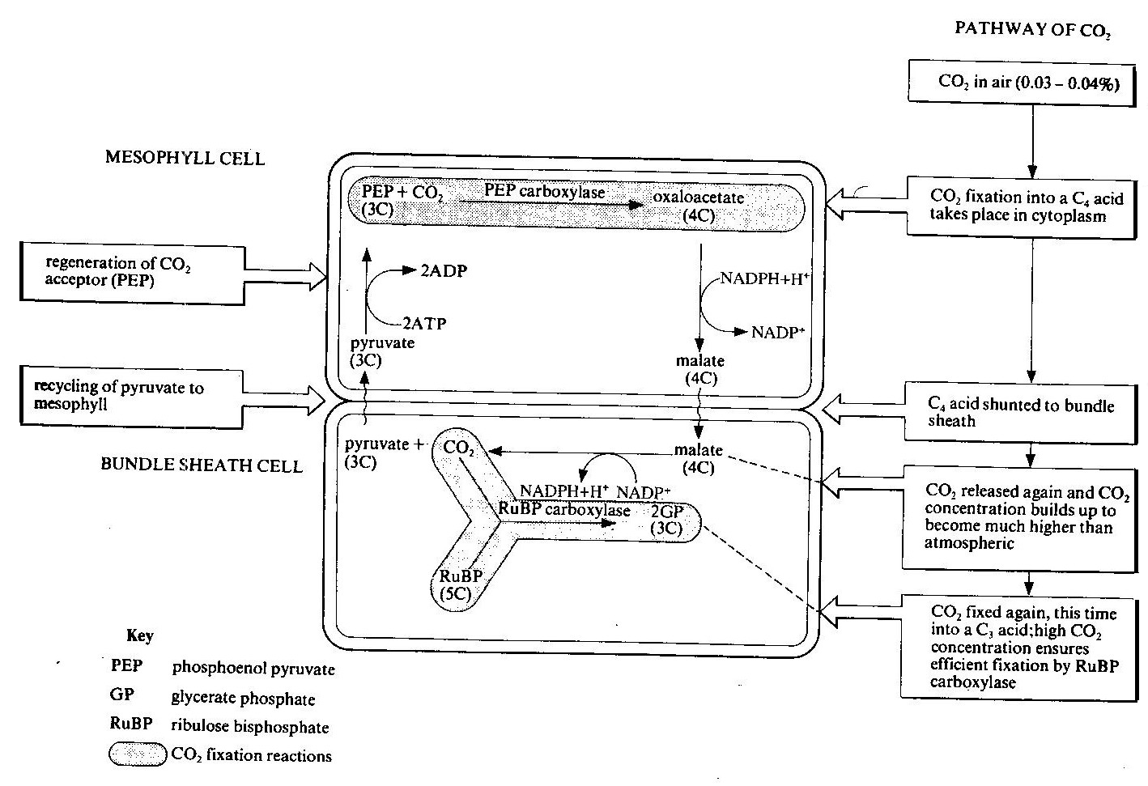
ILLUSTRATION OF HATCH SLACK-PATHWAY

Note.1
1. Carbondioxide fixation in the mesophyll cells does not occur inside their chloroplasts because they lack RUBP carboxylase enzyme.
2. PEP carboxylase has a much higher affinity for CO₂ than RUBP carboxylase and therefore a higher level of carbondioxide is fixed into the carbohydrate metabolism leading into formation of a larger amount of food, energy than in C₃ plants.
3. Because of the high concentration of CO₂ fixed by PEP under the catalysis of PEP carboxylase initially, RUBP carboxylase only catalyses fixation of CO₂ rather than oxygen. The high CO₂ concentration in the chloroplast of the bundle sheath cells out completes O₂ for RUBP carboxylase active site. Hence prevents photorespiration in C₄ plants ensuring efficient CO₂ fixation by RUBP carboxylase.
4. Its high affinity for CO₂ also makes it unable to fix oxygen instead of CO_{2.}

NOTE.2
- Most C₄ plants register a high photosynthetic yield in tropics and subtropics regions with high temperatures and high light intensity due to their ability to fix a high concentration of CO₂.
- C₄ plants yield more food materials than C₃ plants because they dont photorespire.

C₄ plants have a characteristic leaf Anatomy which is described as kranz anatomy which is the arrangement 2 distinct rings of leaf cells around the vascular bundles each with a different type or form of chloroplasts, where by the inner ring of cells are called the bundle sheath surrounded the outer ring referred to as the mesophyll cells.
Chloroplasts in the C4 plants show some Dimorphism i.e. they exist in two forms. Those of the bundle sheath cells have rudimentary grana where as the grana are prominent in the mesophyll cells.

The kranz anatomy illustration diagram.
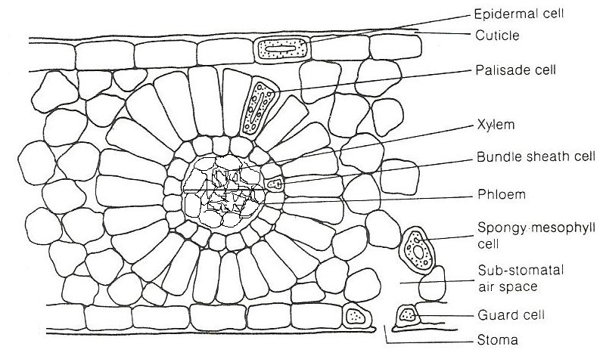

Differences between bundle sheath and mesophyll cells of the C4 plant
Mesophyll cells/chloroplasts | Bundle sheath cells/chloroplasts
- Many and large grana | Lack grana and if present they are very few and small.
- Lack RUBP carboxylase enzyme | Has RUBP carboxylase enzyme
- A high concentration of NADPH ,ATP and oxygen are produced due to high activity of PSII | A low concentration of NADPH ,ATP and oxygen are produced.
- There is no carbondioxide fixation due to lack of RUBP carboxylase | There is carbondioxide fixation
- Have high PEP carboxylation | Have high RUBP carboxylation
- They have a low concentration of starch formed | They have a high concentration of starch formed
- The light dependent reactions occur at a high rate. | The light dependent reactions occur at a low rate.

SIGNIFICANCE OF HATCH-SLACK PATHWAY
Advantages | Disadvantage
lC₄ plants ably photosynthesize at very low CO₂ concentration (e.g. in dense tropical vegetation) because PEP carboxylase enzyme has a very high affinity for carbon dioxide.  lConcentric arrangement of mesophyll cell produces a smaller area in relation to volume for better utilization of available water and reduce the intensity of solar radiations.  lPhotorespiration, which inhibits growth in C₃ plants is avoided / reduced in C₄ because (1) the CO₂ fixing enzyme PEP carboxylase does not accept oxygen (2) RUBISCO enzyme inside the bundle sheath cells is shielded from high oxygen concentration by the ring of palisade cells.  l The CO₂ fixing enzymes in C₄ plants are more active at hot temperature and high illumination, therefore photosynthesis occurs rapidly at low altitude, hot and brightly lit tropical conditions than in C₃ plants.  lThe productivity of C₄ almost four times greater than in C₃ because:  (1) of the increased rate of CO₂ uptake caused by (i) large internal leaf surface area (ii) short CO₂ diffusion distance (iii) CO₂ steep diffusion gradients  (2) The bundle sheath cells in which dark reactions occur have (i) a large photosynthetic surface area enabled by un-usually large chloroplasts (ii) lack of grana on which O₂ would be produced, so no photorespiration.  (3) the Palisade cells in which light reactions occur have large grana to increase the photosynthetic surface area. | l The CO₂ fixing enzymes in C₄ plants are less active at cool temperature and low illumination, therefore photosynthesis occurs slowly at high altitude with cool temperature and in low light intensity of temperate conditions.
Advantages and significance of the c4 path ways
- It makes C₄ plants more adapted to high light intensities and temperatures of the tropics due to higher optimum temperatures of PEP carboxylase for Co₂ fixation.
- Dimorphic nature of the chloroplast limits photorespiration greatly leading to efficient fixation of CO₂ by RUBP carboxylase and higher yield i.e. higher productivity in C₄ plants
- PEP carboxylase does not accept O₂ thus limiting photorespiration
- closing of stomata during the day by desert plants does not affect the rate of photosynthesis due to large stores of large CO₂ at night as malate
- The high affinity of PEP carboxylase for CO₂ leads to high productivity of photosynthesis.
- Because they can reduce the aperture of their stomata during high light intensity and hot conditions, they lose less water by transpiration.

Dis advantages
- Consumes a lot of energy compared to C₃ path ways.
- CO₂ fixation and hence the rate photosynthesis is limited by ATP in cooler, moist temperate regions because in such conditions; it requires external energy.

COMPARISON OF C₃ AND C₄ PLANTS
Similarities
Both:
(1) contain RUBISCO enzyme
(2) Depend on light for their reactions
(3) Show CO₂ fixation phases
(4) Have RuBP as CO₂ acceptor
(5) Form several same organic products e.g. GALP, PGA, sucrose
(6) Have the calvin cycle

Diff | C₃ PLANTS | C₄ PLANTS
structural | Lack Kranz anatomy | Exhibit Kranz anatomy
structural | All chloroplasts have identical structure(have one type of chloroplast) | Chloroplasts are dimorphic (have two types of chloroplasts ) e.g. those of palisade cells have grana yet are lacking bundle sheath cells.
Physiological | l CO₂ acceptor is a 5-Carbon RuBP  l CO₂ fixation occurs once  lPhotorespiration occurs  lLess photosynthetically efficient  lG.P is the first organic product  lEnzymes are more efficient at lower temperatures(20-25⁰C)  l Use only RUBISCO enzyme for CO₂ fixation  l Compensation point is attained at higher CO₂ concentration | l CO₂ acceptor is a 3-Carbon PEP  l CO₂ fixation occurs twice  lNo photorespiration  lMore photosynthetically efficient  lOAA is the first organic product  lEnzymes are more efficient at high temperatures(30-35⁰C)  l PEP carboxylase and RUBP carboxylase enzyme are used  l Compensation point is attained at lower CO₂ concentration
 | Oxygen is an inhibitor of photosynthesis | Oxygen is not an inhibitor of photosynthetic process
 | Grows at a low rate | Grows at a high rate
Note
C₃ plants can survive best in an environment of C₄ plants
-Low temperature -Regions of high temperatures
-In low light intensity -in high light intensity
-Low oxygen levels -In high CO₂ levels
-In high CO2 levels - RUBP carboxylase has a higher affinity for CO₂

PHOTORESPIRATION
Is the light dependent uptake of oxygen by RUBP carboxylase and output of CO₂, which mainly occurs in C₃ plants.
Its wasteful process in which carbon fixation in C₃ plants is prevented due to the light dependent uptake of oxygen by RuBP carboxylase (RUBISCO enzyme) and release of carbondioxide

HOW PHOTORESPIRATION AFFECTS PLANTS

When C₃ plants are exposed to low carbondioxide concentration (or high oxygen concentration) e.g. when stomata close to reduce water loss, RuBP carboxylase catalyses the reaction between RuBP and oxygen to form a 2-carbon compound; phosphoglycolate, which is oxidized to release carbondioxide.

This means that carbondioxide and oxygen do compete for the active site of the enzyme. This makes oxygen to be a competitive inhibitor during carbondioxide fixation. Because RUBP carboxylase enzyme catalyses fixation of both of CO₂ and O₂ due to the affinity it has for both of them, it can be referred t as RUBISCO/Ribulose bisphosphate carboxylase-oxygenase enzyme.

When the carbondioxide concentration is high, RUBISCO enzyme catalyses the reaction between RuBP and carbondioxide to form a 3-carbon compound; 3-phosphoglyceric acid/G.P, which undergoes several reactions to form sugar useful to the plant.

However, when C₃ plants are exposed to low carbondioxide concentration or high oxygen concentration, instead of RUBP carboxylase accepting CO_{2 ,}accepts o₂ leading to the production of one PGA/G.P molecule and a phosphoglycolate. This reduces PGA yields by ½.
During photorespiration RuBP carboxylase catalyses the fixation of oxygen by RuBP to form one molecule of phosphoglycerate/G.P and a 2-carbon compound; phosphoglycolate, which is oxidized to release carbondioxide.
Plants recover the lost carbon in the phosphoglycolate by converting it into PGA/G.P through a series of reactions that occur in 3 cell organelles i.e. chloroplast, peroxisomes and mitochondria.
Phosphoglycolate is immediately dephosphorylated into glycolate.
In abide to recover another molecule of G.P, two molecules of glycolate via a series of reactions are used to form one molecule of G.P and one remaining carbon atom is lost in form of CO₂ without net production of ATP.

Mechanism of photorespiration
It is estimated that Photorespiration therefore reduces the potential yield of photosynthesis by 30-40%.
Therefore C₃ plants are less efficient in production of photosynthetic products than C₄ plants which do not photorespire or less photorespire.
C4 plants do not photorespire or do it it at a very low rate because they have PEP carboxylase enzyme with a much higher affinity in fixing a high for CO2 and highly efficient in fixing a high concentration of CO₂ which is shunted into the bundle sheath cells by malate.
The high concentration of CO₂ is accumulated in the bundle sheath cells increases the efficiency of RUBP carboxylase in fixing CO₂ whereby it does not fix O₂ as well as it is in C₃ plants.

Characteristics of photorespiration
- carbon lost as CO₂ is never retrieved
- ATP and reduced NADP are consumed
- Increased of CO₂ concentration lowers the affinity of RUBP carboxylase for O₂ therefore inhibits photorespiration.
- occurs in 3 organelles
- It is favored by higher temps (tropics) in case of C₃ plants because stomata aperture narrows leading to lower CO₂ concentration.
- it occurs in the presence of light
CONDITIONS for photorespiration
- Low CO₂
- High O₂ concentration
- High light intensity
- High temperatures

Dis advantages of photorespiration:-
- it cuts the yield of photosynthesis by half
- There is loss of carbon and reduces the productivity of the plant.

CRASSULACEAN ACID METABOLISM (CAM) PHOTOSYNTHESIS
These are plants that fix CO₂ into organic Compounds i.e. citrate and malate in the absence of light .In the presence of light , the organic acids malate decompose to release CO₂ ( decarboxylation ) which is used in the synthesis of sugars via the C₃ path way.
Or
A type of photosynthesis in which CO₂ is taken in at night via open stomata, fixed by phosphoenol private carboxylase into OAA, stored as organic acid (mainly malate) which is later decarboxylated during daytime, refixed and CO₂ is assimilated in the Calvin‐cycle when stomata are closed. CO₂ enters the leaf and fixed at night through the PEP system. The enzymatic conversion /breakdown of the mallic acids formed during day provide a supply of CO₂ for C₃ pathway/Calvin cycle.
Biochemically CAM resembles C4 plants only that in C4 plants CO2 fixation by PEP carboxylase and RUBP carboxylase occurs simultaneously but separated in space in CAM plants, the enzymes act in the same cells .i.e. mesophyll cells but separated in time.
CAM is a modified form of C₃ photosynthesis adopted by approximately 6% of vascular plant species as an adaptation to water deficit in terrestrial and epiphytic plants, with exceptions exhibited by submerged freshwater plants for other reasons.

Examples of CAM plants
Cacti, agaves (sisal), opuntia, Kalanchoe (Bryophyllum), Vanilla (family: Orchidaceae), pineapples (Family: Bromeliaceae), Mesembryanthemum crystallinum (Common ice plant), and Euphorbia milii a.k.a Crown of Thorns plant — a spiny climber with showy red bracts, commonly grown in school gardens

Significance of CAM photosynthesis
For terrestrial CAM plants, there is increased water use efficiency (WUE) in which nocturnal stomatal opening greatly reduces stomatal loss of water as it would in day light.

PHASES OF CAM THROUGH THE DIURNAL COURSE
Phase I: nocturnal CO₂ fixation (atmospheric + respiratory sources) mediated by PEP Carboxylase and accumulation of malate within the vacuole.
Phase II: atmospheric CO₂ fixation at dawn which marks the transition between C₄ and C₃ activity.
Phase III: decarboxylation of malate and fixation of the regenerated CO₂ by Rubisco.
Phase IV: a period of atmospheric CO₂ fixation from the end of Phase III to dusk which latterly incorporates the shift from Rubisco to PEP Carboxylase activity.
CAM plants are a group of mainly succulent plants and are found in the small crassulacaen.
CAM and C4 plants are adapted to drier regions ( deserts ) due to their ability to store CO₂ at night (mainly malate) and decarboxylate during day when the CO₂ up take is greatly reduced since the stomata close to reduce water loss by transpiration.
Factors affecting the rate of photosynthesis
Internal factors
- Structure of the leaf and chlorophyll content
- Influence of enzymes
- Accumulation with in chloroplasts of products of photosynthesis
- Hormones
- Leaf size
- Number of stomata
- Vascular bundles
- Air spaces
External factors
- Quantity and quality of light incident on leaves
- Suitable temperature
- Concentration of carbondioxide in the surrounding atmosphere
- Concentration of oxygen in the surrounding atmosphere
- Availability of water
- Inorganic ions; absence of ions like mg, N and Fe , chlorophyll cant be synthesized
THE PRINCIPLE OF LIMITING FACTORS
The law of limiting factors: It states that: when a physiological/chemical process depends on more than one essential conditions being favourable, its rate at any given moment is limited by the factor at its least favourable valve/nearest its minimum value/in its short supply.i.e its this factor which directly affects the process if its in quantity is changed.
Example photosynthesis cant proceed in the dark because the absence of light limits the process. The absence of will alter the rate of photosynthesis
orAt any given moment, the rate of a biochemical reaction depends upon more than one factor/conditions being favourable; its rate is determined or limited by the one factor which is nearest its minimum value.
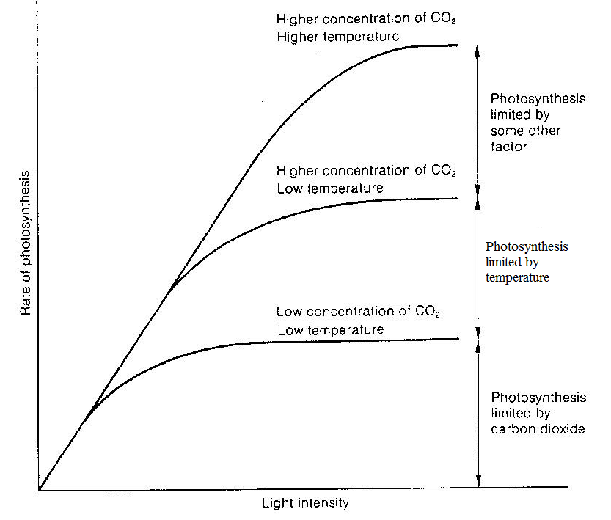
When one factor is favourable e.g. when light is increased the rate of photosynthesis increases until it levels of because another factor other than light intensity limits the rate of photosynthesis. But when the limiting factor such as CO₂ is increased, the rate of photosynthesis further increases until yet another factor like temperature tends towards its minimum and limits the rate of photosynthesis resulting its leveling off.
Salinity
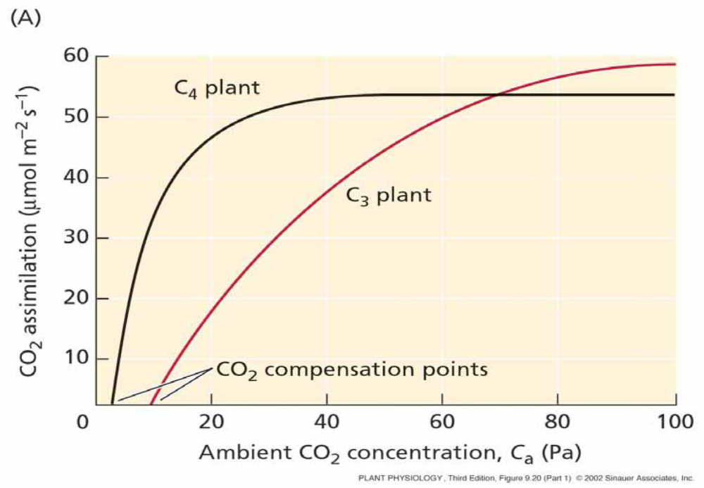
One of the major effects of salinity is osmotic stress, and hence there are intimate relationships to drought stress or water stress. This results in stomata closure in an effort to avoid desiccation, which reduces photosynthesis because uptake of CO₂ reduces.
Rate of photosynthesis estimated as

Effect of carbondioxide

Observation / description | Explanation
l Generally, the rate of photosynthesis increases rapidly with increasing carbondioxide concentration to a maximum at 30 Pa in C4 plants and 90 Pa in C₃ plants and thereafter remains constant. | l RuBISCO attaches carbon dioxide instead of oxygen, because the carbon dioxide concentration is higher than the oxygen concentration.  lMore cells photosynthesize because of the increased carbon dioxide molecules available.
l The rate of photosynthesis is faster in C4 than C3. | PEP Carboxylase of C₄ has a higher affinity for carbondioxide than RuBISCO of C₃ and hence acts faster.
l The overall photosynthetic products are greater in C3 than in C4 | C4 needs more ATP than C3 which generally reduces photosynthetic out put
l The C4 plants are more efficient at lower CO₂ concentration while C3 more efficient at higher CO₂ | l At lower CO₂ concentration in C3 photorespiration reduces the photosynthesis efficiency yet PEP Carboxylase has a high affinity for carbon dioxide
l C₃ plant has a higher compensation point than C₄ | PEP Carboxylase has a high affinity for carbon dioxide
After attaining the maximum, the rate of photosynthesis remains constant in both | It is because other factors limit the process e.g. temperature, light intensity etc.
l At the CO₂ concentration of about 70 Pa, the rate of photosynthesis is equal in both plants
Carbondioxide is a raw material for the dark stage of photosynthesis in that its reduced by hydrogen donated by reduced NADP via a series of reactions to form carbohydrates. HIGH Carbondioxide concentration in the atmosphere increases the rate of photosynthesis significantly.

In the atmosphere, the concentration of carbon dioxide ranges from 0.03 to 0.04 %. However, the highest CO2 level needed for photosynthesis is 0.1%, beyond this optimum CO₂ concentration the rate may reduce due the inactivation or denaturation of the photosynthetic enzymes due to the acidic PH as result of formation of carbonic acid from the reaction of excess CO₂ with water.

Chlorophyll Concentration
The concentration of chlorophyll affects the rate of reaction as they absorb the light energy without which the reactions cannot proceed. When the level of chlorophyll molecules is high the rate of photosynthesis is high because sufficient light energy is absorbed for formation of enough ATP and reduced NADP (NADPH) needed for the dark reactions.

But when the concentration of chlorophyll is low the rate of photosynthesis is low because little amount of light energy is absorbed leading to production of insufficient ATP and reduced NADP (NADPH) needed for the dark reactions. Total absence of chlorophyll results into lack of photosynthesis.

Lack of chlorophyll or deficiency of chlorophyll results in chlorosis or yellowing of leaves. It can occur due to disease, mineral deficiency or the natural process of aging (senescence). Lack of iron, magnesium, nitrogen and light affect the formation of chlorophyll and thereby causes chlorosis.

Temperature
Most reactions of photosynthesis are catalyzed by enzymes; they need an optimum temperature for optimum enzyme activity for high photosynthetic rate.
At temperatures below the optimum (around 0ºC) the photosynthetic rate is reduced due to the inactivation enzymes and when the temperature is increased beyond optimum the rate of photosynthesis reduces until the reactions stop because of denaturation of enzymes until all of them are fully denatured. Different species of plants have different optimum ranges of temperature ,most temperate plants need an optimum range of temperature between 20-25 ºC while the tropical plants need 35-40ºC
Since both the stages of photosynthesis require enzyme activity, the temperature has an affect on the rate of photosynthesis.
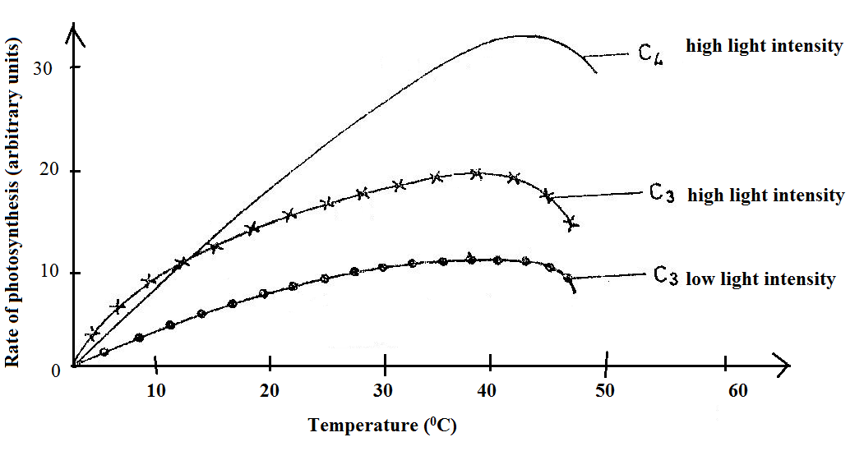

Observation / description | Explanation
lBelow 10⁰C, C₃ rate of photosynthesis is higher than in C₄ above 10⁰C. | lC₄ photosynthetic enzymes are less active in the cold but become more active with increase in temperature.
lThe maximum rate of photosynthesis attained in C₄ is much higher than in C₃ | lThe optimum temperature for enzymes involved in the C₄ cycle is higher than in the C₃ cycle
lAt about 45⁰C, the rate of photosynthesis decreases | lEnzymes controlling photosynthesis are denatured
There is an initial increase in photosynthetic rate to a maximum at about 40-42⁰C, inspite of further increase in temperature | lLight intensity becomes a limiting factor in each of the three cases
lThere is increase in the rate of photosynthesis with increase in temperature until up to at about 40⁰C | lIncrease in temperature activates enzymes to a level beyond which enzyme denaturation occurs.

Water
Water is a metabolite/raw material for photosynthesis. Water is split by light energy to provide hydrogen ions needed in the dark stage of photosynthesis. It also provides electrons which restabilises the PSII/photo system II after it has emitted its electrons.

It is found that even slight deficiency of water results in significant reduction in the crop yield. The lack of water not only limits the amount of water but also the quantity of carbon dioxide. This is because in response to drying the leaves close their stomata in order to conserve water being lost as water vapour through them.

Pollution
Pollution of the atmosphere with industrial gases has been found to result in as much as 15% loss. Soot can block stomata and reduce the transparency of the leaves. Some of the other pollutants are ozone and sulphur dioxide. In fact, lichens are very sensitive to sulphur dioxide in the atmosphere. Pollution of water affects the hydrophytes. The capacity of water to dissolve gases like carbon dioxide and oxygen is greatly affected.

Mineral salts
Mineral salts affect the production of chlorophyll such as nitrates,phosphates,Mg²⁺ nitrogen.in high concentration of mineral ions there is high production of chlorophyll molecules.total absence results in chlorosis hence no photosynthesis will take place.
Oxygen
High concentration of oxygen, mainly in C₃ Plants reduces the rate of photosynthesis because oxygen competes with CO₂ for the active site of ribulose bisphosphaate carboxylase enzyme used to catalyze the fixation of CO₂ by RUBP,carbondioxide acceptor into an unstable 6C intermediate compound, this is the enzyme has an equally high affinity for oxygen unlike CO₂ . Because this enzyme is called RUBISCO (ribulose bisphosphate carboxylase-oxygenase.

Light intensity and Compensation Point
When light intensity is Low the rate of photosynthesis is low. As the intensity is increased the rate photosynthesis also increases. This is because light is used during the light stage of photosynthesis to provide energy in form of ATP and reduced NADP (Nicotinamide adenine dinucleotide phosphate hydrogen).ATP and reduced NADP as products of the light stage are required as raw materials in the dark stage of photosynthesis.
Light is also needed during photolysis of water resulting into production hydrogen. The hydrogen ions produced during photolysis are used to reduce NADP to NADPH +H⁺.
light is used to raise the energy level of electrons of chlorophyll molecules on order for them to be emitted and passed via electron carriers at different energy levels in order to produced energy needed to combine ADP with inorganic Phosphate to form ATP.

As the light intensity is increased the rate photosynthesis also increases However, after reaching an intensity of 10,000 lux (lux is the unit for measuring light intensity) there is no effect on the rate. Very high intensity may, in fact, slow down the rate as it bleaches the chlorophyll. Normal sunlight (usually with an intensity of about 100,000 lux) is quite sufficient for a normal rate of photosynthesis.
When a plant in a region of low light / in darkness is provided with high light intensity, its rate of photosynthesis increases until it equals to the rate of respiration whereby there is no net release of oxygen by the plant to the atmosphere.
When the rate of photosynthesis is equal to the rate of respiration, the plant is said to have reached its Compensation point .this happens at dawn and at dusk.

Light compensation point is that light intensity at which the rate of photosynthesis is exactly balanced by the rate of respiration. At this point, CO₂ is neither evolved nor absorbed i.e. there is no net loss or gain in CO₂ and there is no net loss or gain in carbohydrates and there is no net exchange of O₂ and CO₂.
Compensation point: the point at which the rate of photosynthesis in a plant is in exact balance with the rate of respiration, so there is no net exchange of CO₂ or oxygen. Or
The light intensity at which the photosynthetic intake of carbon dioxide is equal to the respiratory output of carbon dioxide. It occurs during early morning or late evenings
Beyond compensation point further increase in light intensity results in a proportional increase in rate of photosynthesis until light saturation is reached. Beyond this point further increase in light intensity has no effect on the rate of photosynthesis unless some other factors like CO2 has its concentration increased. The time period taken for the plant to reach compensation point is known as compensation period.
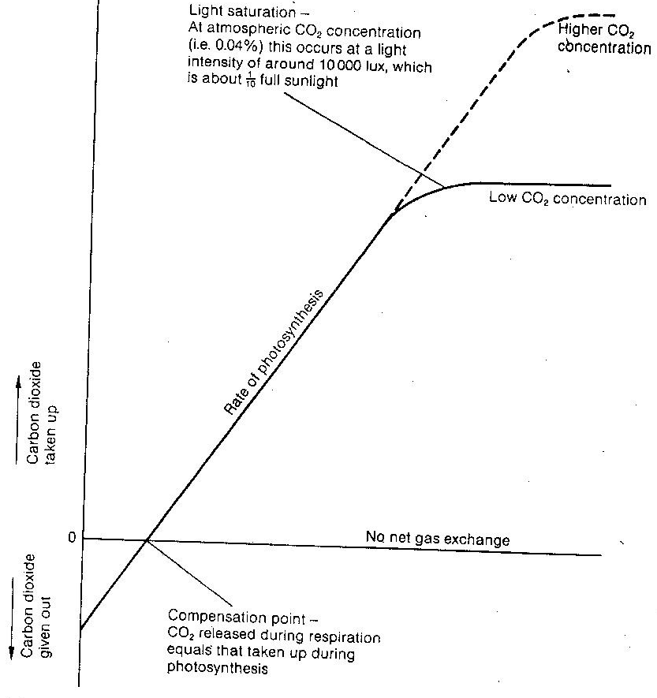
Net gain in sugars (photosynthesis rate exceeds respiration rate)

Net loss of sugars(sugars used in respiration more rapidly than they are produced in phosynthesis).

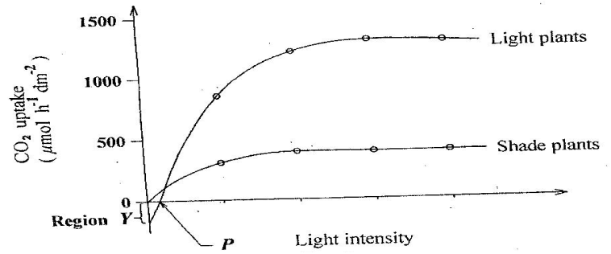

Shade plants have a shorter compensation period than those in bright light/light plant for their maximum and efficient utilization of light
At very low light intensity, shade plants have higher CO₂ uptake, which reduces with illumination.
Light plants have a higher compensation point than shade plants.
At a certain light intensity, the rate of CO₂ uptake is the same in both.
In both, CO₂ increases with increase in illumination to a maximum and then levels off.
Shade plants reach maximum CO₂ uptake at a lower illumination than light plants.
Increased illumination causes a bigger increase in CO₂ uptake in light plants than in shade plants.
Letter P represents compensation point at which CO₂ uptake equals CO₂ ₋out put.
At Y biomass decreases because the rate of respiration exceeds that of photosynthesis.

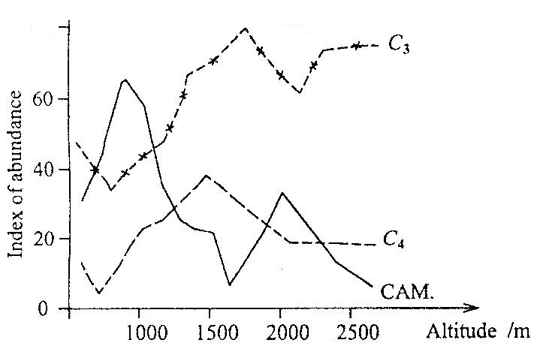
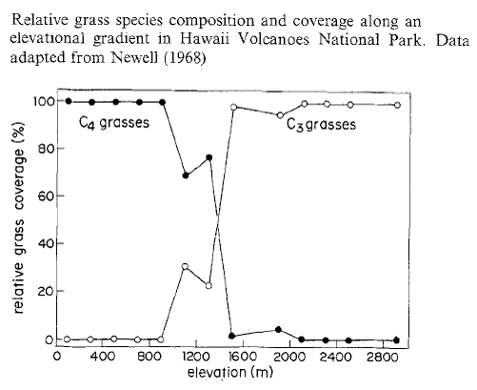
Effect of altitude (and oxygen)

Observation / description | Explanation
lC3 plants are more abundant at high altitude/elevation | lThe decrease in atmospheric pressure at higher altitude decreases the partial pressure of oxygen enables more productivity since photorespiration reduces
lCAM plants are more abundant at low altitude | lEven when temperature is high, nocturnal stomatal opening and closure in day light enables them to reduce transpiration.  lCAM plants that store a lot of malate and due to the thus high osmotic value also a lot of water, are usually less frost resistant than C₃ plants.
lC4 plants are widely distributed at low altitude and slight elevation | lThe enzymes are tolerant to these high temperatures and the Kranz mesophyll anatomy shields RuBISCO in bundle sheath cells from much oxygen to avoid photorespiration.

Significance of the study of the factors affecting photosynthesis
It enables us understand the most important biochemical life sustaining processes. All plants and animals are dependent on the sun for energy, which is made available to them by the process of photosynthesis. Man, like other animals, is dependent on the plants for food. Scientists are constantly working towards developing new varieties of crops which give better yield of crops. With the population explosion and resulting pressure on land resources, the percentage of land available for cultivation is reducing at an alarming rate. This means that in the restricted space, the crops have to yield more. Greenhouse plants and crops in unfriendly freezing conditions have been possible due to the study of the factors affecting photosynthesis.

MEASUREMENT OF RATE OF PHOTOSYNTHESIS
(i) Measure the uptake of CO₂
(ii) Measure the production of O₂
(iii) Measure the production of carbohydrates
(iv) Measure increase in dry mass

Measuring the uptake of water cant work!

l Measuring the Uptake of CO₂
Uptake of CO₂ can be measured with the means of an IRGA (Infra-Red Gas Analyser) which can compare the CO₂ concentration in gas passing into a chamber surrounding a leaf / plant and the CO₂ leaving the chamber. The soil and roots must NOT be in the bag to avoid CO₂ production from respiration
NOTE: CO₂ uptake can also be measured by following the uptake of carbon dioxide labelled with Carbon 14

l Production of carbohydrates
This is a crude method where a disc is cut out of one side of a leaf (using a cork borer against a rubber bung) and weighed after drying. Some weeks later, a disk is cut out of the other half of the leaf, dried and weighed. Increase in mass of the disc is an indication of the extra mass that has been stored in the leaf.
However, you can probably think of several inaccuracies in this method.

l Measuring the increase in dry mass
Dry mass is often monitored by the technique of 'serial harvests' where several plants are harvested, dried to constant weight and weighed - this is repeated over the duration of the experiment so as to have an accurate measure of the surplus photosynthesis over and above the respiration that has taken place. As with most methods, several plants are needed to have replicate measurements which are used to calculate the average and a standard deviation if necessary.

l Measuring the production of O₂
Oxygen can be measured by (a) counting bubbles evolved from pond weed with the Audus apparatus
Requirements
(1) Previously well illuminated aquatic plant e.g. Elodea or Cabomba (2) Test tube (3) Watch (4) Water at room temperature (5) bench lamp to provide light (6) Knife (7) Ruler (8) 0.2 % sodium bicarbonate solution (9) plastic Syringe (10) 500 cm³ glass beaker (11) capillary tube (12) plastic tube connector (13) graduated scale (14) retort stand (15) soft board (16) thermometer
Procedure:
Set up the apparatus as below in TOTAL DARKNESS
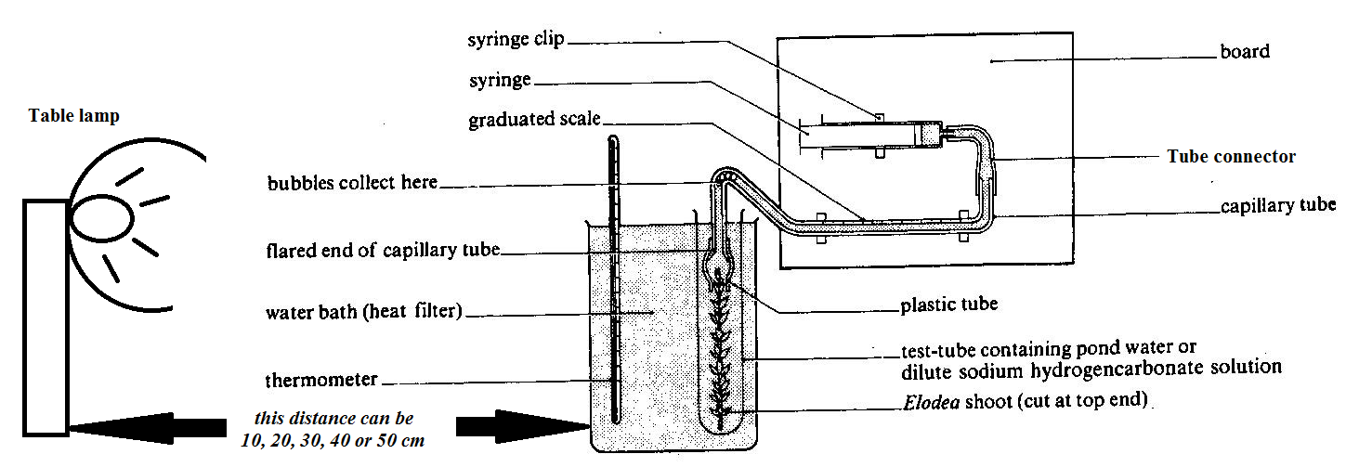

(1) A light source is placed 50 cm away facing the test tube, is powered on and a 5 minutes lapse is allowed to enable the plant adjust to the light intensity.
(2) The length of gas bubble evolved in 10 second, 30 second, and 1 minute intervals is measured by pulling the syringe plunger to draw the bubble slowly along the capillary tube.
(3) Steps 1 and 2 are repeated with the light source placed at 40 cm from the test tube with the plant, then 30 cm, 20 cm, and finally 10 cm.
(4) Lastly the control experiment involves using natural room lighting and repeating the above steps.
Observation / results | Explanation
l A colorless gas which relights a glowing splint evolves from the cut end of the plant. | l The gas is oxygen released from Photosynthetic reactions.
l The rate of gas evolution is directly proportional to light intensity up to a certain illumination i.e. the closer the light source is to the plant, the more oxygen bubbles evolve up to a certain light intensity then remains relatively constant and may decrease.  Determination of amount of gas released  a) if scale is marked in mm³ or cm³: read volume directly  b) if scale is marked in mm: calculate volume from πr²h  π=3.14, r=capillary tube radius, h=distance bubble covers | lThis is because of the increased light intensity which provides more energy for photo-activation of electron flow.  l Increased illumination may not cause any further evolution of oxygen because (1) of light saturation (2) other factors limit the process  l Increased illumination may cause a decrease in bubble evolution because chlorophyll gets bleached with increased illumination.

Precautions to avoid experimental inaccuracies / errors | Explanation / Remedy
l Temperature fluctuation of the water in the beaker | l Thermostatically controlled bath should be used to maintain temperature constant since it affect photosynthetic activity.
l The experiment must be conducted in total darkness | l To avoid effects of external light fluctuations on photosynthesis
l There must be periodical refilling of HCO₃⁻ solution | l To avoid depletion of carbondioxide
l The water should be aerated first. | l To saturate the water with oxygen such that the oxygen evolved does not dissolve into water.
l Each time the light position is adjusted, a 5 minute lapse must be allowed before bubble counting | l To allow the plant equilibrate (adjust) to the new light intensity.
lLight intensity fluaction | lUse voltage that gives constant light for a long time
lTrapped gas bubbles | lSwirl the water weed to release them
l Expel gas before taking another reading | l

NOTE:
l Instead of measuring the length of bubble, bubbles can be counted, but this has several disadvantages (1) Some bubbles may not be seen due to variations in size, which can be avoided by adding a little detergent to lower the surface tension (2) Bubbles may evolve very fast to be counted, especially in much illumination.
lThe percentage of oxygen in the evolved gas is only about 40% because of dilution by (1) dissolved N₂ or other gases released from solution and (2) CO₂ which had accumulated from respiration, and is first displaced into the capillary tubing, especially if the plant had been kept in the dark
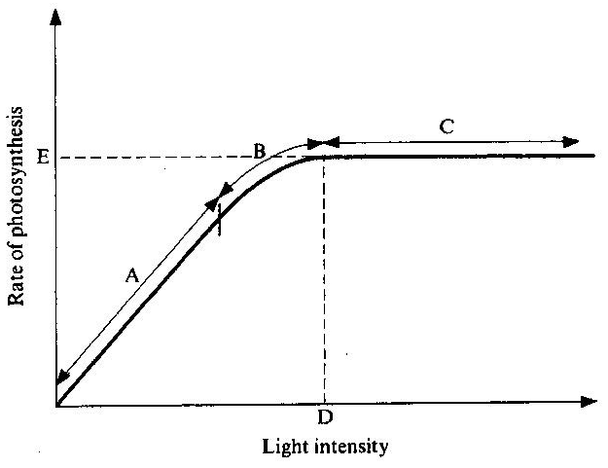
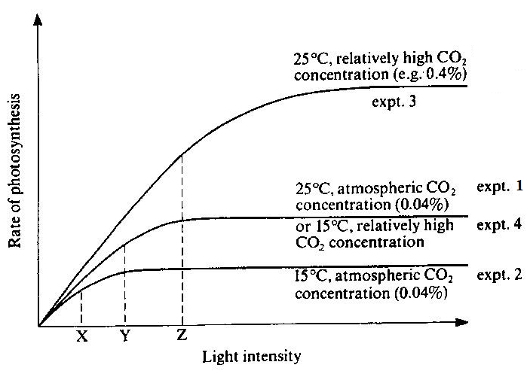
Limiting factor t A: light intensity
Curves represent at B: both light and other factors, at C: light intensity no longer a limiting factor
D represents: light saturation point
E represents: maximum attainable rate of photosynthesis under experimental conditions

X, Y and Z represent: the points at which light intensity ceases being the major limiting factor of photosynthesis in the four experiments because its at these points that increase in light intensity causes an increase in photosynthesis.

EXTRA WORK FOR REVISION (Soper R, et al., 1997; Biological Science, p.212: 7.19 & 7.20)

EVIDENCE FOR LIGHT REACTION IN PHOTOSYNTHESIS
The following evidences indicate that the over all reaction in photosynthesis takes place in two steps: one is light dependent and the other is light independent.

1. Temperature coefficient studies
The rate of photosynthesis of two groups of plants was compared. Both were supplied with an adequate concentration of carbon dioxide. But one group was kept under light of high intensities and other group in light of low intensity. When the rate of photosynthesis were measured at different temperatures it was found that high light group had a Q₁₀ = 2 but the low light group Q₁₀ = 1. Strictly, chemical reactions characteristically have a Q₁₀ from 2 to 3. This fact indicates that at least one of the reaction involved in photosynthesis is of a purely chemical type. This reaction is called as dark reaction. The other reaction of Q₁₀ indicates that one of the reactions proceeds only at the expanse of absorbed light it is called dark reaction. The Q₁₀ of light reaction is 1

2. Flashing light experiments
Photosynthesis involves photochemical and biochemical reactions is also shown by the results of investigations in which plants are exposed to intermittent light. Warburg (1919) obtained higher rates of photosynthesis in Chlorella when it was exposed to rapid and alternate periods of light and darkness instead of continuous illumination. Emerson and Arnold (1932) found that at 25⁰C, the maximum photosynthesis took place when light and dark periods were respectively 10⁻⁵ second and 0.055 second. At 1.1⁰C, maximum photosynthesis could be obtained with the same light period but the dark period has to be increased to 0.4 second. It means that temperature influences reactions of the dark period and reactions of light phase are photochemical.
ENGELMANNS EXPERIMENT ON ACTION SPECTRUM OF PHOTOSYNTHESIS
Description of Engelmanns experiment | Results of Engelmanns experiment
lFilaments of the green alga Cladophora of the genus Pseudomonas are placed in a drop of water on a slide, then illuminated with light of different wavelengths and observed under the microscope.  lThe control experiment involves mounting the alga on a slide in water with aerobic bacteria in total darkness and thereafter exposing the slide to light.  l Observation 1:  The motile aerobic bacteria cluster near to the filaments in the region of blue light (450 nm) and red light (650 nm).  l Deduction 1:  Since the distribution of aerobic bacteria is in response to the concentration of oxygen which is a by-product of photosynthesis, then red and blue light are the most effective for photosynthesis.  l Observation 2:  Motile aerobic bacteria cluster around the edge of the cells adjacent to the chloroplast.  l Deduction 2:  Oxygen is more concentrated near the chloroplast which shows that the chloroplast is the sight of photosynthesis.  l Observation 3:  The aerobic bacteria of the slide previously in the dark are immobile but later cluster around the alga filament on exposure to light. | 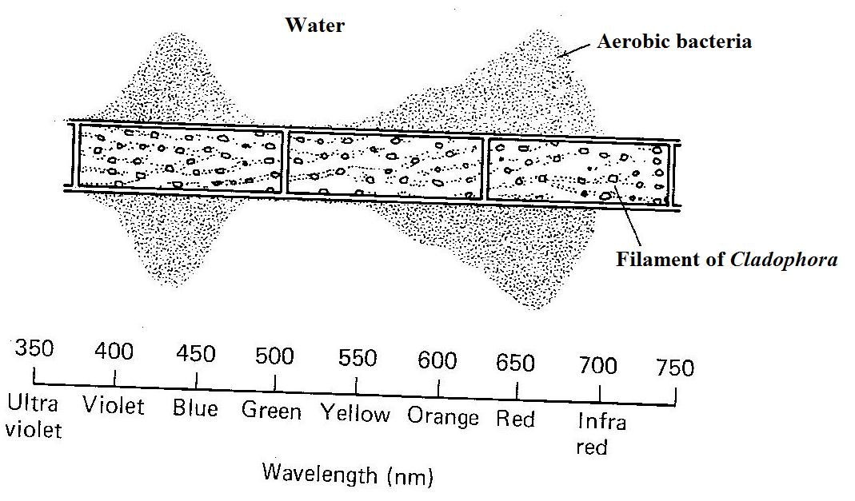  l Deduction 3:  Darkness prevents photosynthesis, which stops evolution of oxygen resulting in anaerobic conditions that donot favour aerobic bacterial activity  l Observation 4:  There is hardly any aerobic bacteria in the ultra-violet, green and infra-red regions of the spectrum.  l Deduction 4:  Light from ultra-violet, green and infra-red regions of the spectrum is hardly absorbed by chlorophylls hence least used in photosynthesis, with no / little evolution of oxygen.

AUTOTROPHIC BACTERIA
Are divided into two groups
- Photosynthetic bacteria
- Chemosynthetic

Both can build up carbohydrates from simple inorganic raw materials but they differ in the way they obtain the necessary energy.
Photosynthetic bacteria
These build/manufacture organic food substances from simple inorganic substances using sun light energy. Sun light energy is trapped by bacteriochlorophyll which is similar but simpler than chlorophyll \a.
Most of them use hydrogen obtained from hydrogen sulphide instead of water to reduced CO₂ via a series of reactions using light energy absorbed by bacteriochlorophyll molecules.
- This partly explains why most photosynthetic bacteria are located at the bottom of shallow water bodies, like ponds where there is a high concentration of hydrogen sulphide from decomposing of dead organic matter of plants and animals by the decomposers, anareobically.
Sulphur bacteria live in bottoms of lakes, ponds and rocks where they obtain H₂S from metabolism of anaerobic decay bacteria.
CO₂ + H₂S [CH₂O] + 2S + H₂O

Sulphur resulting from splitting of H₂S is deposited in bacterial cells.
- Because the bacteriochlorophyll absorbs light from either sides of the absorption spectrum of green plants, the photosynthetic bacteria exist beneath the leaves of green plants as the light absorbed by their bacteriochlororphyll passes through the leaves reaches them.
Chlorophyll of green plants and bacteriochlorophyll do not absorb the same wave length of light. Because bacteriochlorophyll is a simple pigment, can easily be destroyed by high light intensity.
- Therefore photosynthetic bacteria are located beneath the sea weeds to hide themselves from high light intensity, thereby preventing their bacteriochlorophyll from destruction by high light intensity.
Also their light saturation levels are low in that they need low light intensity for efficient photosynthesis to occur.

Some bacteria however don not use hydrogen sulphide as source of hydrogen to reduce CO₂.
Example 1 Blue green bacteria use water as a source of hydrogen to reduce CO₂.
Example 2 purple non sulphur bacteria use organic compounds to provide hydrogen for reduction of CO₂ (Photochemoautotrophs or to reduce other organic compounds (heterotrophic)

CHEMOSYNTHESIS

Chemosynthesis: chemical process in which inorganic chemicals are oxidized to provide energy to living organisms for the synthesis of organic compounds.
Importance of chemosynthesis
The chemical activities of the organisms involved bring about nutrient cycling; for example:
- Nitrosomonas and Nitrobacter bacteria are involved in nitrification in plants.
- Thiobacillus catalyse the conversion of sulphur containing compounds to sulphates which are directly useful to plants.

CHEMOSYNTHETIC BACTERIA
These manufacture organic food substances from simple inorganic substances using energy from oxidation of inorganic substances rather than sugars.

EXAMPLES

- Iron bacteria: these obtain energy from oxidation of ferrous iron into ferric iron.
Fe²⁺ _{(aq)} oxygen Fe³⁺_{(aq)} + energy

- Colourless sulphur bacteria: these oxide sulphur using oxygen into sulphates and energy is released.
S _{(s)} oxygen SO₄⁻ _{(aq)} + energy

H₂S + 2O₂ Thiobacillus SO₄²⁻ + 2H⁺ + Energy

- Nitrifying bacteria: these oxide ammonia into nitrites the into nitrates and energy is released.

Mechanism of chemosynthesis in some bacteria
Nitrosomonas
NH₃ + 3O₂ HNO₂ + H₂O + energy (79 kcals)

Nitrobacter
HNO₂ + O₂ HNO₃ + energy (22 kcals)

Nitrification is a means of increasing, cycling of nutrients into usable form of nitrates by the plants, hence increases soil fertility and productivity of primary producers.
In ecosystem there is denitrifying bacteria and nitrogen fixating bacteria which are important in nutrient cycling.

Denitrifying bacteria: these reduce nitrates and nitrites into the atmospheric nitrogen, in order to obtain oxygen for respiratory activities in an environment without enough oxygen.e.g water logged soils.
In other words, they reduce the level of nitrates from the soil by pseudomonas denitrificans and thiobacillus denitrificans.

Nitrogen fixing bacteria: these reduce nitrogen using hydrogen and energy in form of ATP under catalysis of nitrogenase enzyme to form ammonia which is used to form amino acids and then proteins and can be oxidized to nitrites and then nitrates

N₂ + 3H₂ ATP NH3
Nitrogenase
The chemosynthetic bacteria utilize the energy from the chemical oxidation of inorganic chemicals to synthesize organic compounds, some of which are subsequently oxidized in respiration to yield energy for metabolism.
6CO₂ + 12H₂S C₆ H₁₂O₆ + 6H₂O + 12S

Substrate | Main product | Chemosynthetic bacteria | Habitat
Ammonium (NH₄⁺) | Nitrite (NO₂⁻) | Nitrosomonas and Nitrococcus | Soil
Nitrite (NO₂⁻) | Nitrate ((NO₃⁻) | Nitrobacter | Soil
Sulphur (H₂S) | Sulphate (SO₄²⁻) | Thiobacillus | Decaying organic matter
Ferrous (Fe²⁺) | Ferric (Fe³⁺) | Ferrobacillus / Iron bacteria | Streams flowing over iron rocks
Hydrogen (H₂) | Water (H₂O) | Hydrogenomonas | Soil

WAYS BY WHICH NITROGEN IS FIXED IN THE SOIL:
1. Mutualistic bacteria in root nodules i.e.rhizobium bacteria
2. Free living nitrogen fixing bacteria in the soil.e.g.azotobacter and clostridium
3. Action of lightning
4. Industrial fixation i.e harber process

Differences between photosynthetic bacteria and eukaryotic plants

Eukaryotic plant | photosynthetic bacteria
- They use chloroplasts | They lack chloroplasts
- Oxygen is produced as a by-product | No oxygen production except in blue green bacteria
- Water is the source of hydrogen for CO₂ reduction | Other compounds other than Water serve as the source of hydrogen for CO₂ reduction except in blue green bacteria
- Their photosynthetic membranes are stacked together to form grana | They are not stacked together
- They involve use of photo system II | photo system II NOT involve except in blue green bacteria
- They are more efficient photo synthetically | They are less efficient photo synthetically
- They use chlorophyll pigment for light absorption | They use bacteriochlorophyll for light absorption except in blue green bacteria which uses chlorophyll.
- Their photosynthetic membranes are located within the chloroplasts | Their membranes exist as extensions of plasma membrane called chromatophores except blue green bacteria where they are distributed throughout the cytoplasm.

SECTION A (40 MARKS)

1. The table below shows the effect of temperature on the rate of photosynthesis in two grasses, Agropyron and Bouteloua

Leaf temperature (ºC) | Rate of photosynthesis(arbitrary units)
Leaf temperature (ºC) | Agropyron | Bouteloua
10 | 23 | 10
15 | 26 | 15
20 | 30 | 19
25 | 31 | 24
30 | 30 | 30
35 | 27 | 35
40 | 20 | 39
45 | 10 | 38

(a) Plot the data on graph paper. (08 marks)

(b) From your graph, determine the rate of photosynthesis at 22ºC for each grass. (02 marks)

(c) Account for the variation in the rate of photosynthesis for Agropyron.
(i) 10 - 25ºC. (06 marks)
(ii) 25 - 45ºC. (04 marks)

(d) Compare the two graphs. (04 marks)

(e) (i) Describe the photosynthetic mechanism which is likely to occur in the cytoplasm of the mesophyll cells of Bouteloua. (04 marks)
(ii) Explain the physiological significance of the mechanisms described in (e) (i) above.
(04 marks)
(f) Basing on the data provided, outline the physiological and ecological advantages of Bouteloua over Agropyron. (05 marks)

(g) What is meant by CAM? (03 marks)

SECTION B (60 MARKS)
2. (a) What is photorespiration? (02 marks)
(b) Summarize the main features of photorespiration. (06 marks)
(c) How does photorespiration account for the known effects of carbon dioxide and oxygen concentration on rates of photosynthesis? (10 marks)
(d) What environmental conditions favour photorespiration? (02 marks)

3. (a) Define the term C₃ plant and C₄ plant. (03 marks)
(b) What would be the effect of lowering oxygen concentrations on:
(i) C₃ photosynthesis,
(ii) C₄ photosynthesis?
Explain your answers. (12 marks)
(c) Explain the difference in effect of increasing carbon dioxide levels above normal atmospheric concentrations on the rate of photosynthesis in C₃ and C₄ plant. (05 marks)

4. Discuss the biogeography of C₃ and C₄ plant species (20 marks)

SECTION A (40 MARKS)
1. An investigation was made to determine the effect of carbon dioxide concentration and light intensity on the productivity of plant in a green house.
The productivity was determined by measuring the rate of carbon dioxide fixation in milligrams per dm² leaf area per hour.

The investigation was conducted at three different light intensities: 0.05, 0.25 and 0.45 (arbitrary units), the highest approximating to full light.
A constant temperature of 22ºC was maintained throughout.
The results are indicated in table below:

Carbon dioxide  concentration (ppm) | Productivity at different light intensities (mg dm⁻² h⁻¹)
Carbon dioxide  concentration (ppm) | At 0.05 units light intensity | At 0.25 units light intensity | At 0.45 units light intensity
300 | 12 | 25 | 27
500 | 14 | 30 | 36
700 | 15 | 35 | 42
900 | 15 | 37 | 46
1100 | 15 | 37 | 47
1300 | 12 | 31 | 46

(a) Using the same axes, graphically represent the information in the table. (09 marks)

(b) For the experiment at 0.25 units light intensity:
(i) What is the effect of increasing carbon dioxide concentration on the productivity of the plant? (05 marks)
(ii) Explain the effect of increasing carbon dioxide concentration on the productivity of the plant. (12 marks)
(c) (i) Carbon dioxide concentration of 300 ppm is equivalent to that of the atmosphere . For each of the light intensities, work out the maximum increase in productivity that was obtained compared with that at 300ppm. (03 marks)
(ii) Comment on the effect of changing light intensity on productivity. (04 marks)

(d) Why was the temperature kept constant during the experiment? (02 marks)

(e) From the experiment, state the optimum conditions for productivity of the plant at 22ºC (02 marks)
(f)Suggest why even with artificial lighting, glass house crops generally need to have more carbon dioxide added when temperatures are low than when temperatures are high. (03 marks)

SECTION B (60 MARKS)
3. (a) (i) Describe P. Mitchels physiology that occurs in the chloroplast. (10 marks)
(ii) Compare the physiology above with that which occurs in the mitochondrion.
(05 marks)
(b) How is the chloroplast suited to its functions? (05 marks)

4. Outline the processes involved in the synthesis of carbohydrates in C₃ plants. (20 marks)

3. Explain:
(a) Why flowering plants do not breathe. (10 marks)
(b) The adaptations of plants for capturing maximum light. (10 marks)

SECTION A (40 MARKS)
1. In an investigation to study the effect of light intensity on the physiology of Spirogyra, its amount of Phospoglyceric acid (PGA), Ribulose biphosphate (RuBP), and Sucrose, were determined at different intervals of time in presence of light.
At the 35th minute, light was removed completely.
The graph showing the variation of the amount of PGA, RuBP and Sucrose with time:
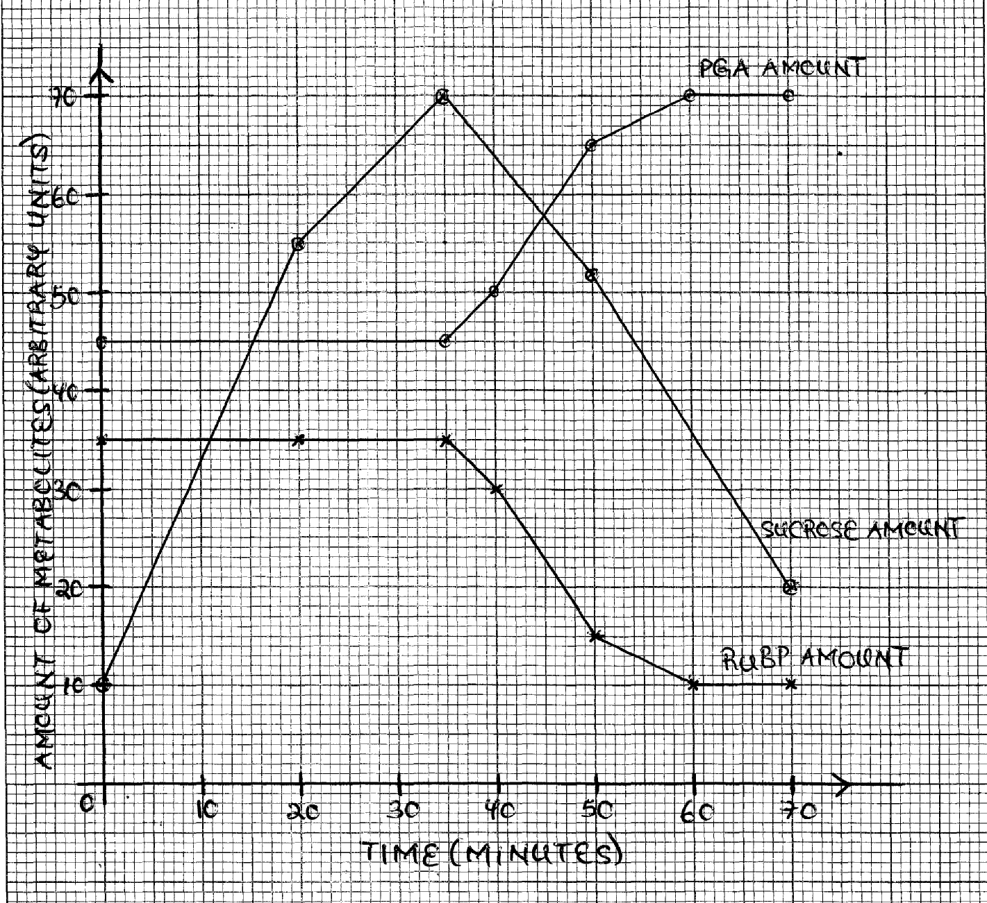

Study the graph carefully and answer the following questions:
(a) Compare the changes in the amount of PGA and RUBP with time. (05 marks)
(b) Account for the changes in the amount of:
(i) PGA,
(ii) RuBP,
(iii) Sucrose, with time (15 marks)

(c) Draw a sketch graph for the changes in the amount of PGA and RuBP with time, if carbon dioxide had been used in the experiment instead of sunlight. (02 marks)

(d) Explain the changes in the amount of:
(i) PGA,
(ii) RUBP, on the sketch graph with time. (10 marks)

(e) Describe the respiratory metabolism within the cytoplasm of living cells, beginning from PGA. (05 marks)

(f) Compare the metabolism of PGA in the chloroplasts with its respiratory metabolism within the cytoplasm of the C₃ plants. (03 marks)

SECTION B (60 MARKS)
2. How is the structure of the following tissues suited to their functions?
(a) Epidermal tissue. (10 marks)
(b) Phloem. (10 marks)

3. Discuss the modifications of the parenchyma in different parts of a plant to suit it to its functions. (20 marks)

4. (a) Explain the distribution of mechanical tissue in plants. (10 marks)
(b) Describe the distribution and function of different types of plant meristem. (10 marks)

SECTION A (40 MARKS)
1. The table below shows the rates at which carbon dioxide is taken up (+) and released (-) from the stem of a herbaceous plant and from a single leaf of the same species at different light intensities:
Light intensity  (arbitrary units) | Uptake (+) and release (-) of carbon dioxide  (mg 50cm⁻² hr⁻¹)
Light intensity  (arbitrary units) | Stem | Leaf
0.0 | -0.6 | -0.6
1.0 | -0.3 | +0.7
2.5 | +0.4 | +2.9
4.0 | +0.9 | +4.7
5.0 | +1.1 | +5.4
7.0 | +1.7 | +6.1
11.0 | +2.6 | +6.4

The figure below shows the response of sun plants and shade plants to changes in light intensity:
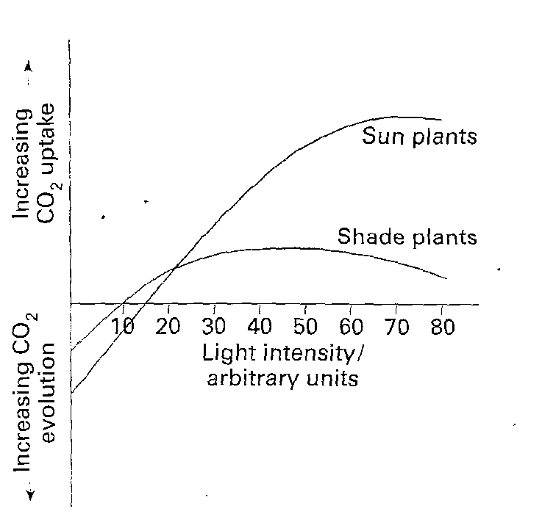

(a) Represent the data in the table on a single set of axes. (08 marks)

(b) (i) Explain the state of the leaf at light intensity of 0.6 arbitrary units. (04 marks)
(ii) Calculate the rate at which carbon dioxide is used in photosynthesis by 100 cm² of the leaf at a light intensity of 1 arbitrary unit. (02 marks)

(c) Explain the shape of the graph line for the leaf above a light intensity of 5 arbitrary units. (06 marks)
(d) Explain, in terms of anatomical and physiological factors, why:
(i) The leaf takes up carbon dioxide faster than the stem? (06 marks)
(ii) The leaf and stem release carbon dioxide at the same rate in darkness? (02 marks)

(e) From the figure, compare the effect of light intensity on the two groups of plants.
(06 marks)
(f) Suggest explanations for the differences stated in (e) above. (06 marks)

